Hierarchical Framework for Disaster Assessment:

Fusing Social-Media Signals with Satellite Imagery Analysis

Abstract
The use of rapid measures to control the effects of disasters is critical in enhancing the speed of crisis response. The present work is based on a two-step, hierarchical, empirical approach, which first analyzes the social-media posts (CrisisMMD v2.0) to identify informative posts and crisis-relevant humanitarian categories, and subsequently segmentation of building-damage on high-resolution satellite imagery (BRIGHT dataset). Models in Stage 1 are BERTweet to classify informative tweets, CardiffNLP RoBERTa to classify humanitarian tags with denoising and class-balancing, and a ConvNeXt-Tiny image model with text-based damage models to do multimodal fusion. Stage-2 is based on a lightweight U-Net that is trained on post-event satellite tiles. In Stage 1 activities, the highest scores of our best models were macro-F1 (0.79 informativeness), 0.53 humanitarian and 0.57 multimodal damage severity. The U-Net attained 0.337 validation and 0.284 test scene-wise IoU. We find that a hierarchical triage-to-mapping pipeline is possible in disaster analysis.
1. Introduction & Research Question
Disaster assessment is based on two different modalities:
- Social-media feeds, which communicate instant, crowd-sourced situational information
- Satellite imagery presents spatially accurate images of physical damage.
There are complementary strengths and weaknesses of each modality. The speed of social media is high but noisy, whereas the speed of satellite images is slow, but correct to obtain and process. Precedent research in crisis informatics has demonstrated the utility of both modalities individually but few studies have been done to evaluate hierarchical pipelines which utilize one modality to direct another.

Research Question
Can a hierarchical framework that first analyzes social-media signals and then processes satellite imagery produce reliable, interpretable disaster-damage assessments?
To overcome this, we operatically implemented a two-stage workflow:
- Stage 1: filtering tweets by CrisisMMD into informative and not-informative, humanitarian types, and (in Task 3) damage severity using text, images, and text+image composite.
- Stage 2: define 2-damage areas in BIGHT satellite images.
It is not to unite the two datasets in direct proportion, but to check every phase of the hierarchical design with the help of two high-quality datasets that can be considered the representation of the real-world disaster data sources.
2. Methods and Experimental Design
Datasets, preprocessing, model architecture, training configuration, and reproducibility controls are all summed up in this section.
2.1 Datasets
CrisisMMD v2.0 (Twitter multimodal disaster dataset)
- Total posts: ~18,000 tweets containing text + images
- Tasks used:
  - Task 1: Informativeness (binary)
  - Task 2: Humanitarian classification (8 categories following the normalization)
  - Task 3: Severity of damage (3 categories, little or none, mild, severe) All official train/dev/test splits unaltered.
- All official train/dev/test splits used exactly as provided
- Strong TSV loader, which is used to deal with encoding noise and bad rows.
BRIGHT (Building Damage Assessment Dataset)
- 4,246 post-event satellite scenes (1024×1024, 8 - 12-bit)
- Labels: pixel-level building-damage masks
- There are a lot of scenes without pre-event imagery post-only model applied.
- Tiled into 36,832 patches (256×256) using sliding windows
- Only tiles with ≥500 damaged pixels retained to avoid trivial background-only training
- Scene-based splits:
  - Train: 25,915 tiles
  - Dev: 5,493
  - Test: 5,424

2.2 Preprocessing
Text (CrisisMMD)
- URL normalization, user-tag normalization, de-emojiing (if emoji installed)
- Hashtag segmentation and whitespace cleanup
- Maximum length: 128 or 160 tokens depending on task
- Tokenizer: BERTweet / CardiffNLP RoBERTa
Images (CrisisMMD)
- Verified 100% image availability using robust path resolver
- All images resized to 224×224 for ConvNeXt
- Standard ImageNet normalization
Satellite Images (BRIGHT)
- .tif files read using tifffile (channel inference included)
- Percentile stretching used only for visualization
- Tiles stored as .npy for fast I/O during training
- Dataloader includes safe flips to avoid negative-stride issues (important on Windows)

2.3 Models
Stage 1 (CrisisMMD)
Task 1: Informativeness
- Model: vinai/bertweet-base
- 2-class linear classifier
- Optimizer: AdamW, 3 epochs, LR = 2e-5
- Early stopping on validation F1
Task 2: Humanitarian Categories
Best-performing configuration ("even-more" model):
- Base model: cardiffnlp/twitter-roberta-base
- Training denoising: keep only rows with label_text_image == "Positive" for training split (6,126 rows)
- Class balancing via un-sampling to 3,000 examples per class
- Loss: FocalLoss + label smoothing
- Scheduler: cosine warmup (10%)
- 6 epochs
Task 3: Damage Severity
Two pathways:
- Text-only classifier (same RoBERTa tokenizer)
- Image classifier (ConvNeXt-Tiny pretrained on ImageNet22k)
- Weighted multimodal fusion:
  - Combine text & image probabilities:
$$p_{\text{fused}}=α⋅p_{\text{img}}+(1-α)⋅p_{\text{text}}$$
  - Best $α=0.60$

Stage 2 (BRIGHT Satellite Segmentation)
U-Net Architecture
Custom lightweight U-Net:
- Encoder depth: 4
- Base channels: 32
- Loss function: 0.6·BCE + 0.4·Dice
- Mixed precision (torch.amp) for speed
- Optimizer: AdamW (3e-4)
- Early stopping on dev IoU
- Training length: 8 epochs

2.4 Reproducibility
- Random seed: 42 (NumPy, Python, PyTorch, CUDA)
- All models, splits, artifacts saved in:
  - artifacts_stage1/ (CrisisMMD)
  - artifacts_stage2/ (BRIGHT)
- Code executed on Windows with CUDA (verified via logs)
3. Results and Analysis
3.1 Stage 1 - CrisisMMD Results
Task 1 - Informativeness (BERTweet)

Metric | Test Score
Accuracy | 0.8444
Macro-F1 | 0.7945
Precision | 0.8189
Recall | 0.7784

Interpretation:
Model reliably distinguishes informative vs non-informative disaster tweets.
Task 2 - Humanitarian Classification (CardiffNLP RoBERTa)
Metric | Test Score
Accuracy | 0.6267
Macro-F1 | 0.5347
Precision | 0.5504
Recall | 0.5711

Interpretation:
Performance is challenging due to 8-way imbalance and noisy labels, but macro-F1 above 0.53 indicates signal learning.
Task 3 - Damage Severity
Image-only (ConvNeXt-Tiny)
Metric | Test Score
Accuracy | 0.610
Macro-F1 | 0.550

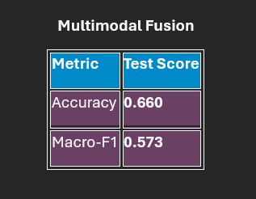
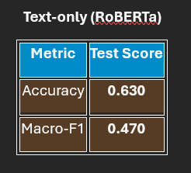

Fusion outperforms both individual modalities.
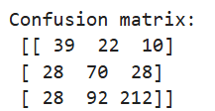
Figure: Confusion Matrix corresponding to ‘Task 3 (Damage) - robust image resolver + ConvNeXt-Tiny + FocalLoss’
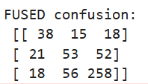
Figure: Confusion Matrix corresponding to Multimodal Fusion (Text+Image)
3.2 Stage 2 - BRIGHT Satellite Segmentation
Validation Performance (Best Checkpoint)
Metric | Dev Score
IoU | 0.337
F1 | 0.495

Test Performance (10-scene fast evaluation)
Metric | Test Score
IoU | 0.284
F1 | 0.437
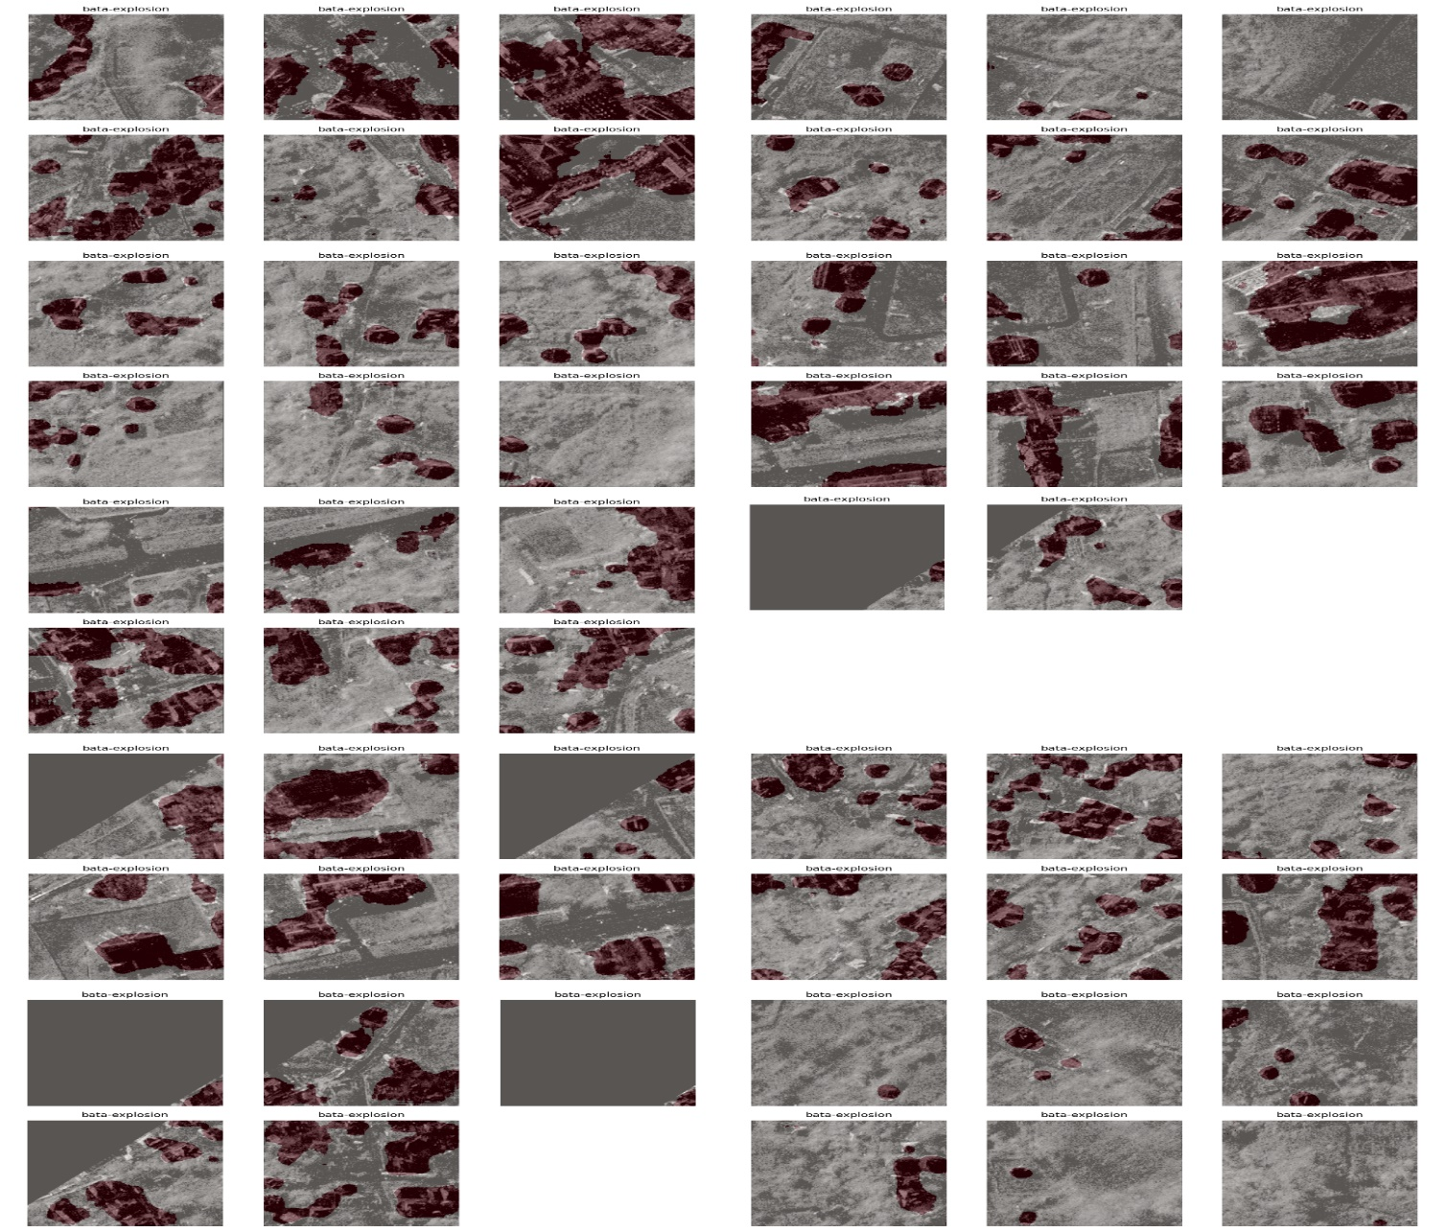

Figure: Visual Damage Predictions for the Bata-Explosion Event
The montage confirms that our U-Net learns meaningful spatial patterns of destruction not random noise and highlights how damage clusters form within the affected region.

4. Discussion and Interpretation
Key findings:
- Text models are also good at the high-level semantic interpretation of disaster tweets.
- Image models are used to do what a text fails to pick up, particularly structural damage.
- Complementarity is continuously affirmed through fusion.
- UNet works fairly well in case of post-only inputs and event-wise heterogeneity.
Limitations:
- Humanitarian labels are unbalanced and noisy → lower F1.
- BRIGHT dataset has no pre-event images of numerous scenes → limits change detection.
- The signature of satellite damage, depending on the type of event (wildfire, earthquake, explosion), is very different.
- Other CrisisMMD activities have weak correlation with pixel-level goals of BRIGHT.

5. Reflection on Methodology
Strengths:
- Strong engineering: robust TSV loader, image path resolver, tiling, safe dataloaders
- Reproducible training pipeline (seeded, deterministic loaders)
- Extensive experimentation: baseline → improved → multimodal fusion
Weaknesses:
- No hyperparameter sweep due to runtime constraints
- Tile-level segmentation does not guarantee whole-scene consistency
- CrisisMMD → BRIGHT linkage is conceptual (because datasets are unrelated)
Potential methodological risks:
- Class imbalance (especially humanitarian categories)
- Denoising may remove legitimate but noisy training examples
- Segmentation evaluation limited to 10-scene sample due to time

6. Conclusion & Future Work
Conclusion
We implemented and validated a hierarchical disaster-assessment workflow combining social-media classification (CrisisMMD) with satellite-based building-damage segmentation (BRIGHT). Results show strong performance in informativeness classification (F1=0.79), meaningful humanitarian tagging (F1=0.53), effective multimodal disaster-severity classification (F1=0.57), and credible U-Net segmentation (IoU up to 0.337). These provide evidence that a layered triage-to-mapping pipeline is technically feasible.
Future Work
- Build unified multimodal model using vision-language fusion across social + satellite.
- Use pre/post Siamese U-Net for true change detection on BRIGHT.
- Scene-level aggregation for more stable IoU on satellite images.
- Event-specific fine-tuning (LoRA) to reduce domain shift.
- Deploy a small Gradio interface for browsing disaster scenes.

7. References
[1] CrisisMMD v2.0 Dataset.
[2] Xiaolong et al., BRIGHT Dataset.
[3] Nguyen et al., "BERTweet: A pre-trained language model for English Tweets", 2020.
[4] Barbieri et al., "TweetEval and Twitter-RoBERTa", 2021.
[5] Ronneberger et al., “U-Net: Convolutional Networks for Biomedical Image Segmentation,” 2015.
[6] Loshchilov & Hutter, "AdamW Optimization," 2017.
[7] Lin et al., "Focal Loss," 2018.

